REACH Facilities Update!
February 2018

Hello everyone!
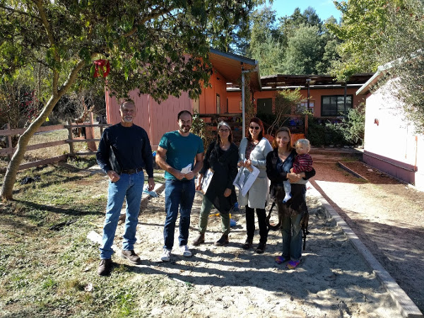
As part of the newly formed Facilities Committee, we’re sending everyone an update on the facilities plan and progress at REACH. Many of you have probably seen news about new play areas, the new play structure, and many other things, so this is just a chance to update everyone on how these are progressing.
We have such a beautiful campus at REACH. But it did come to us with its own set of challenges. One of those is that there were no real plans for the site – no surveys, no good blueprints, no schematics, etc.
Oriana (pictured far right) has tackled the site survey – contracting surveyors to come in and take precise measurements of everything. This survey is critical to progress with our plans.
Oriana (who is a REACH parent and works for the County) is our Facilities Committee star! If you see her, she deserves a high-five!
Lisa Howard of BayTree Design Architects (pictured middle), has taken all the great parent, student and staff feedback from earlier in the year and has produced some great initial site plans that have us all really excited!
These initial plans were reviewed by the Committee, but the site survey will now enable BayTree Designs to finalize them making sure everything is in compliance with State and County rules and regulations. Once we receive the final draft of the site plans will hold community meetings for input and feedback. Stay tuned for parent meetings along these lines.
In the meantime, Thress Roder from Monster Construction (pictured far left) has done a wonderful job on our Central room (which many of you have seen), as well as the grading work to prepare the back playground area.
As we are waiting on the site survey to be finished, and for the final master plan to be approved, there are various other improvements in the works – we have completed a new roof coming on the middle school building, new fencing near the basketball court and of course the new play structure that will kick-off some off the awesome playground improvements we have in store!
As the plan starts to come together, stay tuned for volunteer opportunities. Helping improve the school’s facilities is a great way to spend your volunteer hours!
Best,
The Facilities Committee
Paul, Cheryl, and Oriana

